What is Amazon VPC?

Amazon Virtual Private Cloud (Amazon VPC) enables you to launch AWS resources into a virtual network that you've defined. This virtual network closely resembles a traditional network that you'd operate in your own data center, with the benefits of using the scalable infrastructure of AWS.

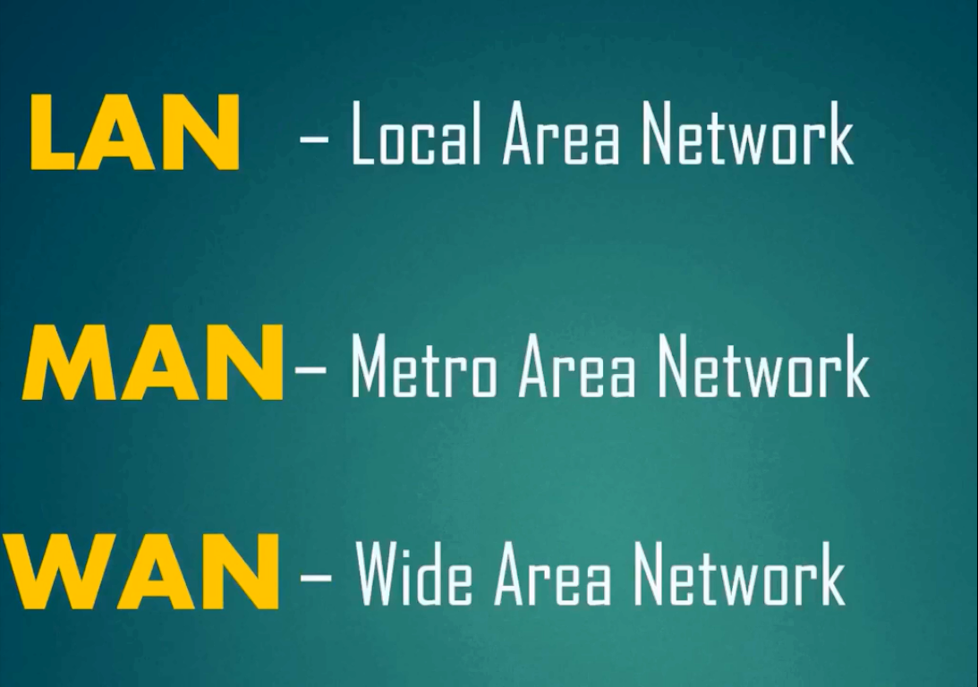

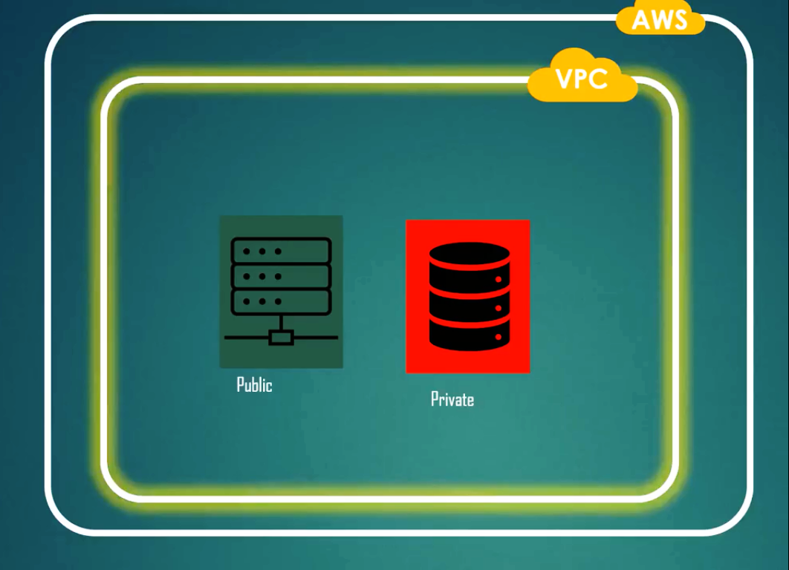

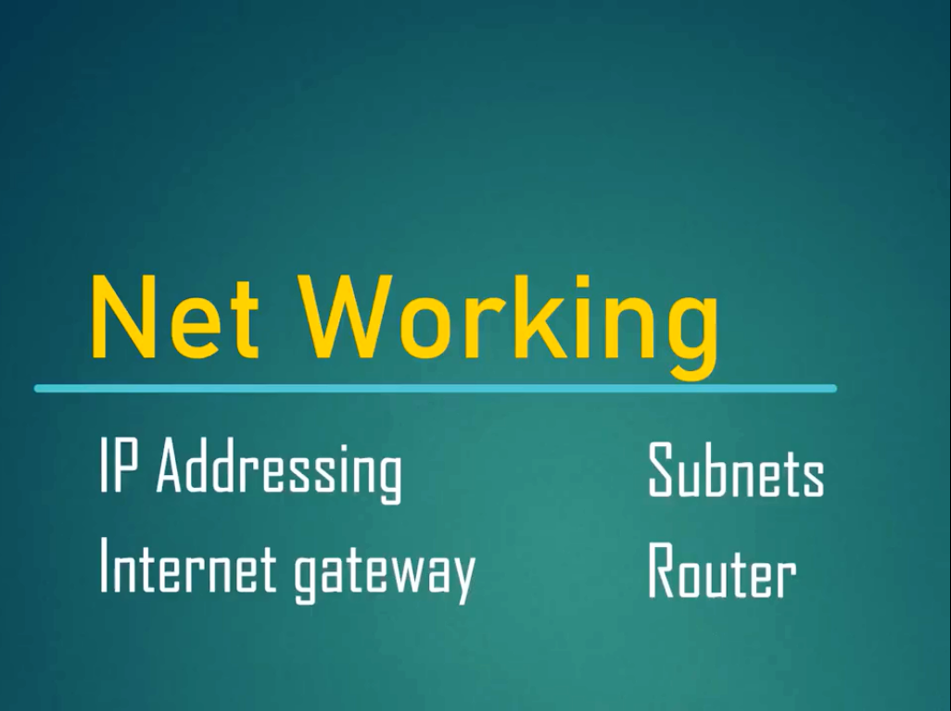

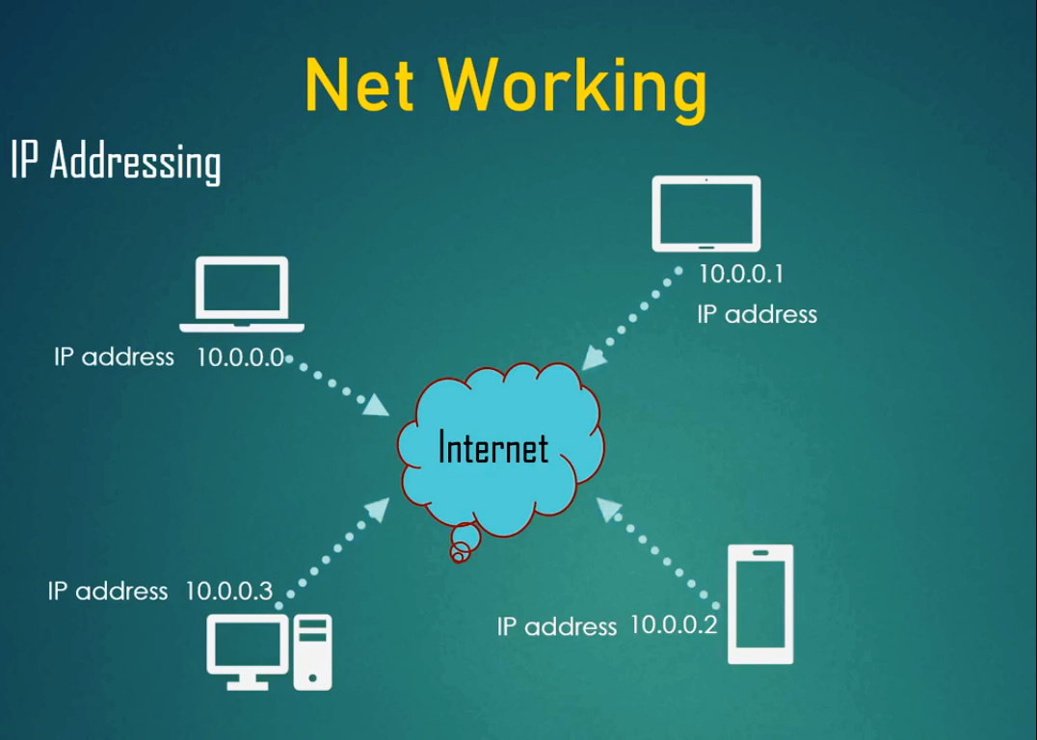

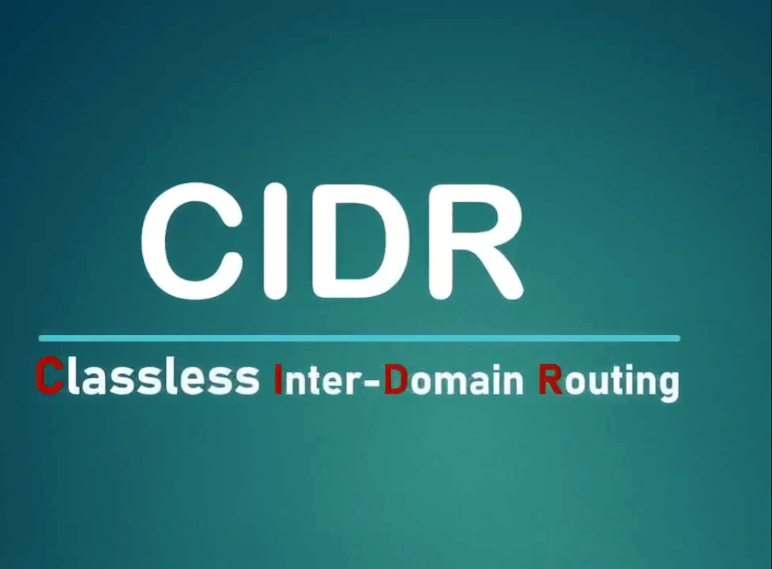

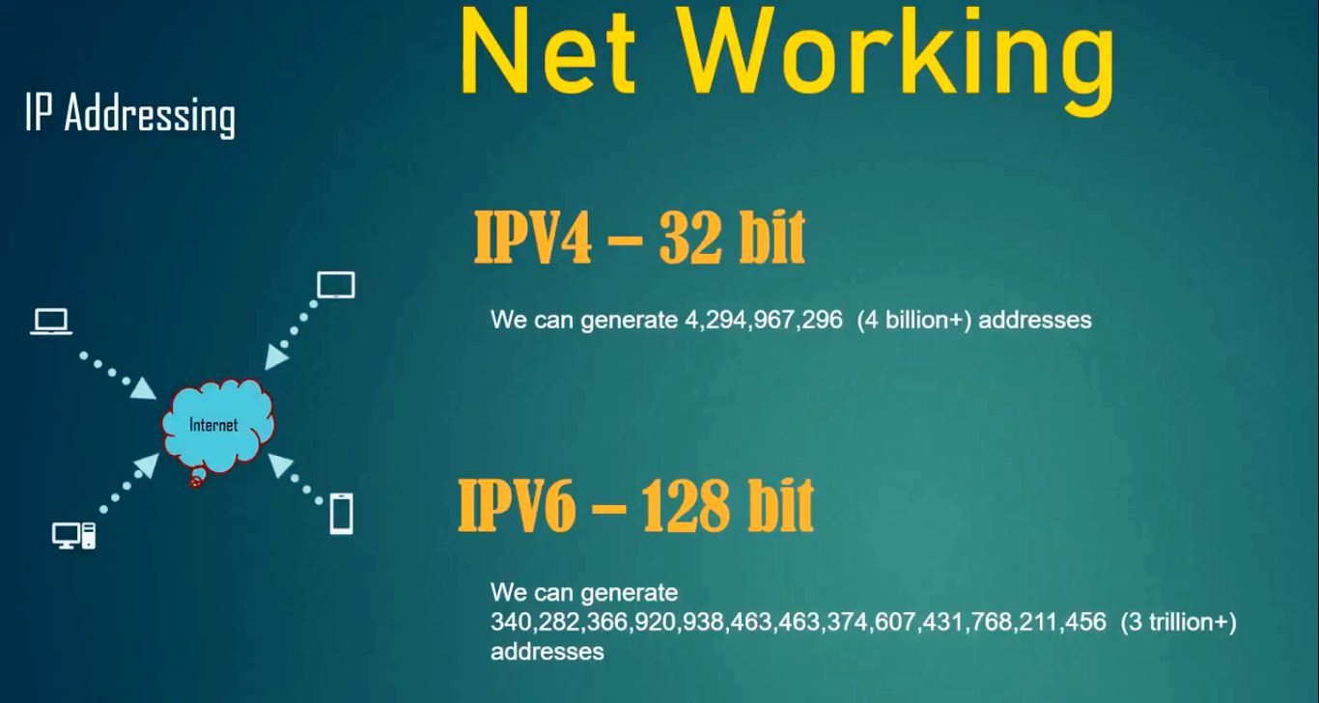

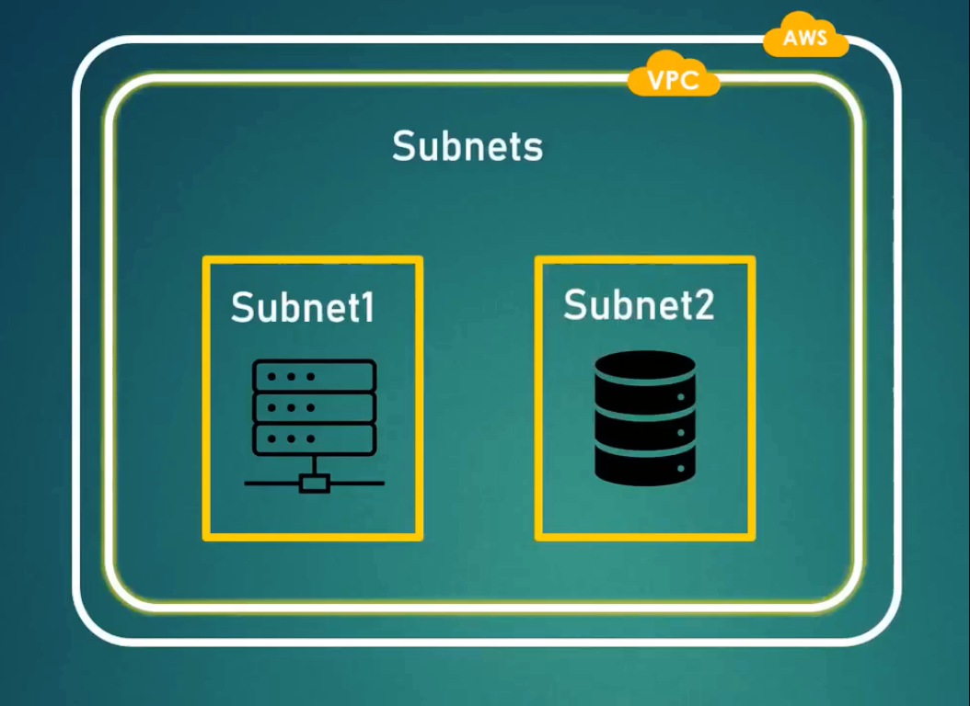

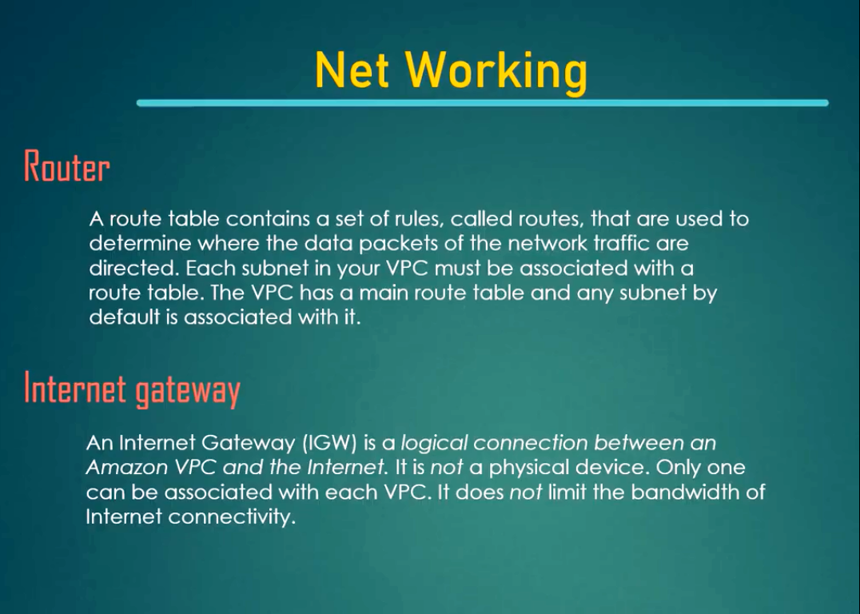

VPC Architecture

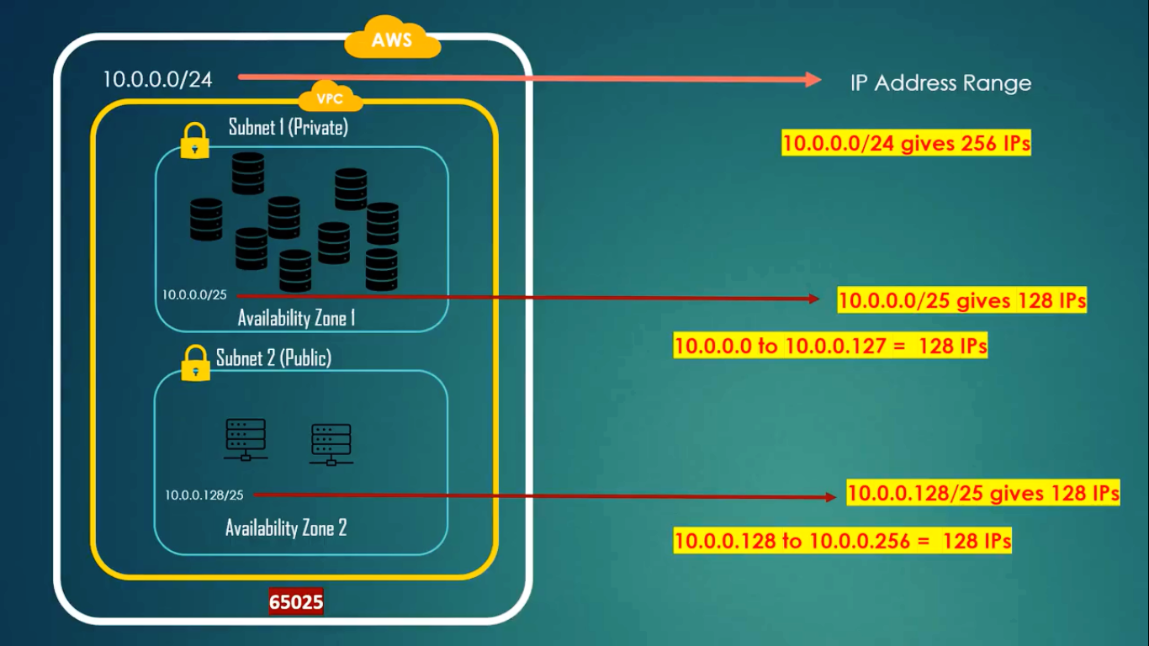

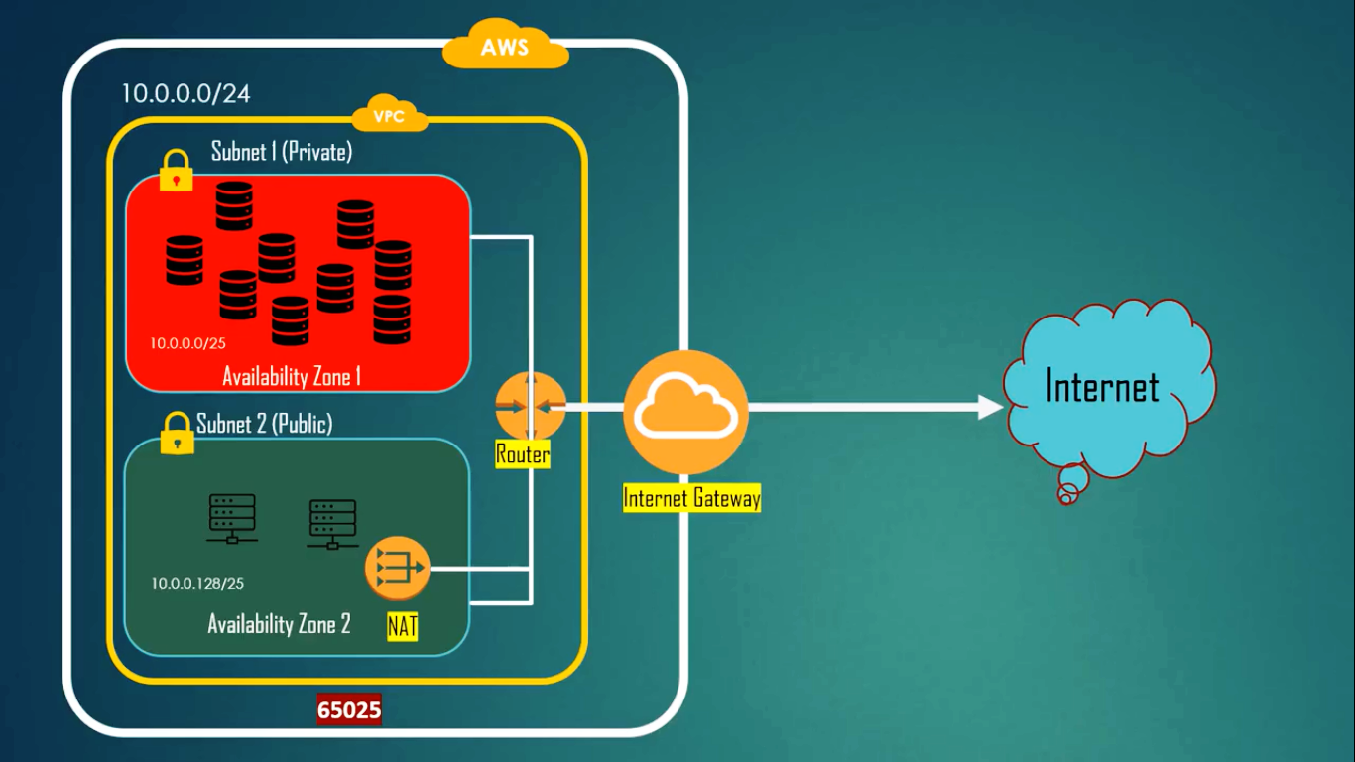

1. We can mention the no of ip addresses we need while creating VPC.
2. No of ip addresses are given on no of servers we create.
3. In general, ip addresses are taken in 2n order. Ex: 22 , 23 , 24 , 25  etc.

CIDR Range Setup:

1. Class Less Inter Domain Routing
2. We mention no of ip addresses needed in CIDR range.
3. In the following example, each section is called an ‘octet’.
4. In total 4 octets are available
5. Each octet contains 8bits of memory.
6. Each bit can have an value range from 0-255.

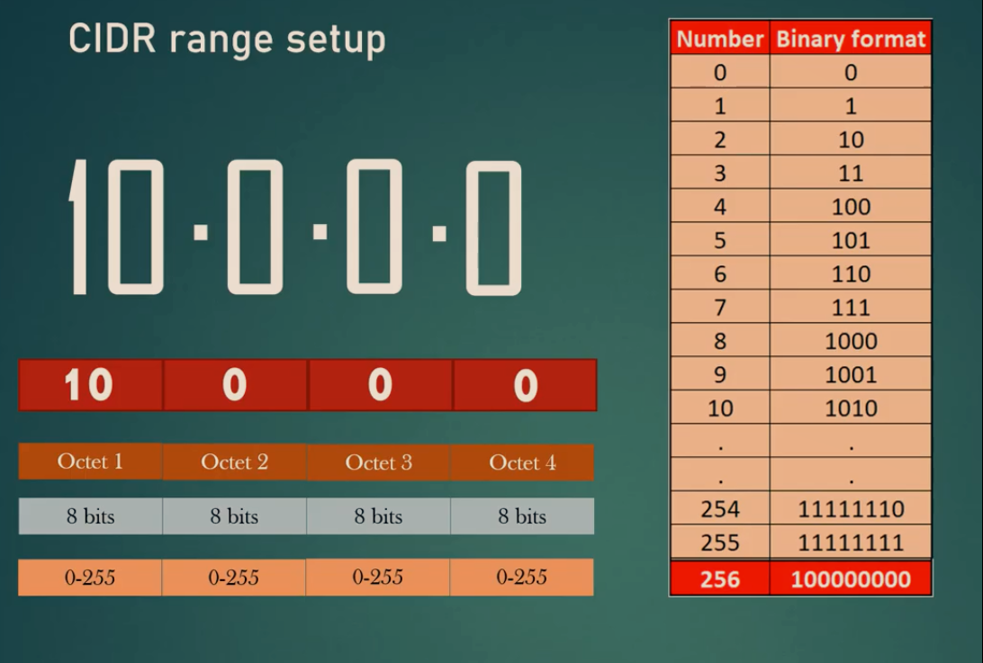

1. We can select no of ip addresses we needed in CIDR range.
2. We call it as ‘net mask’ ranges from 16 to 32.
3. While defining net mask in CIDR, we can give no of ip’s from 16 to 28.
4. Rest of the four ip ranges 10.0.0.0/29, 30, 31, 32 are reserved by aws. So we cannot use those.

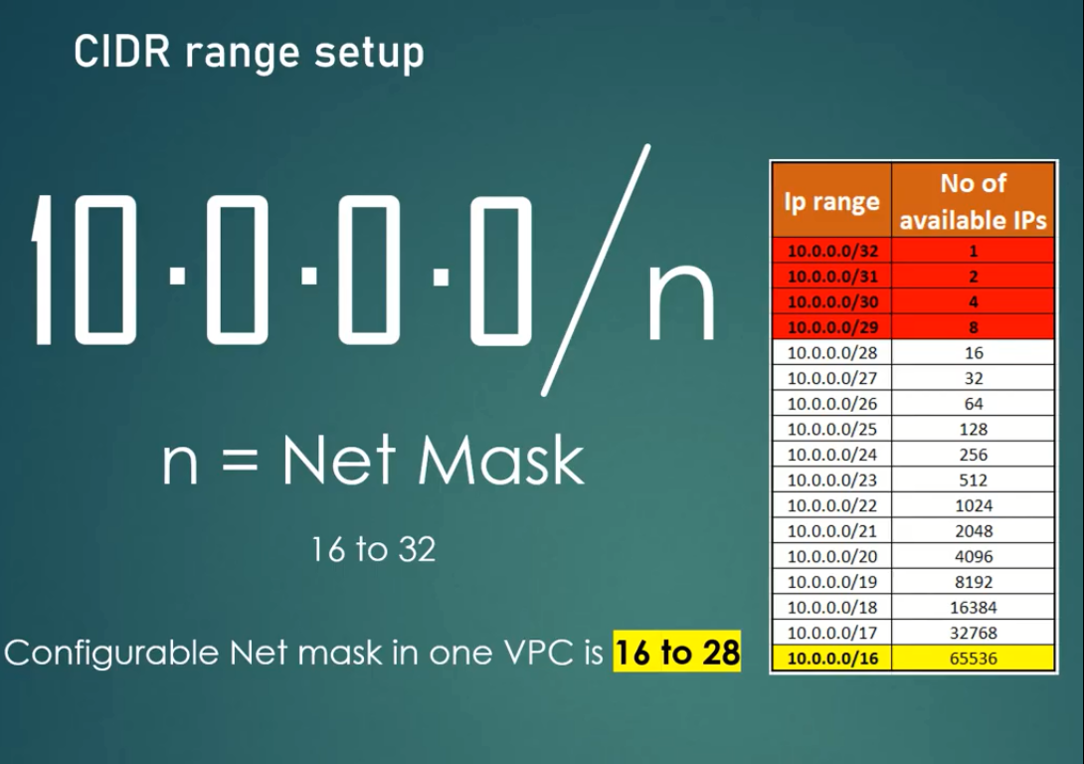

IP Mask Range: 16 – 32

Example:

10.0.0.0/24

32-24 = 8

28 = 256 ips generates

Order: 0 - 255

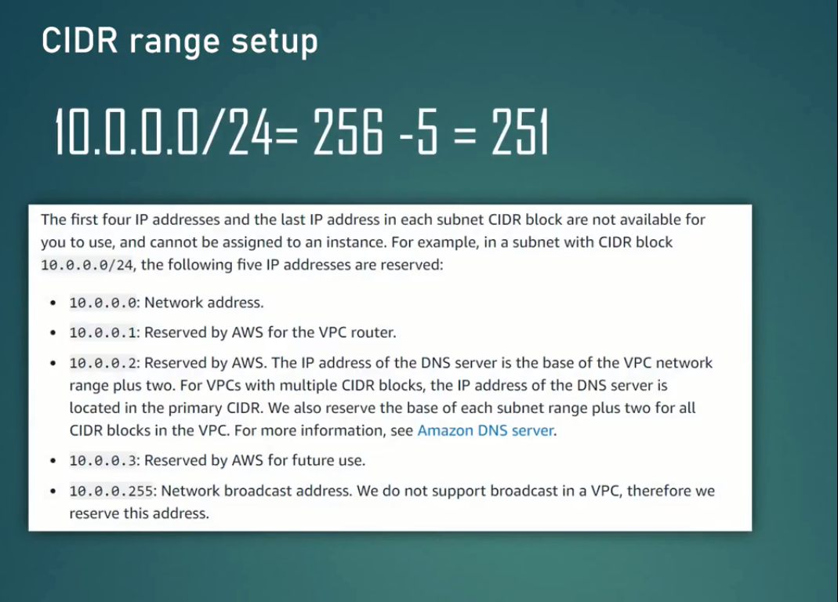

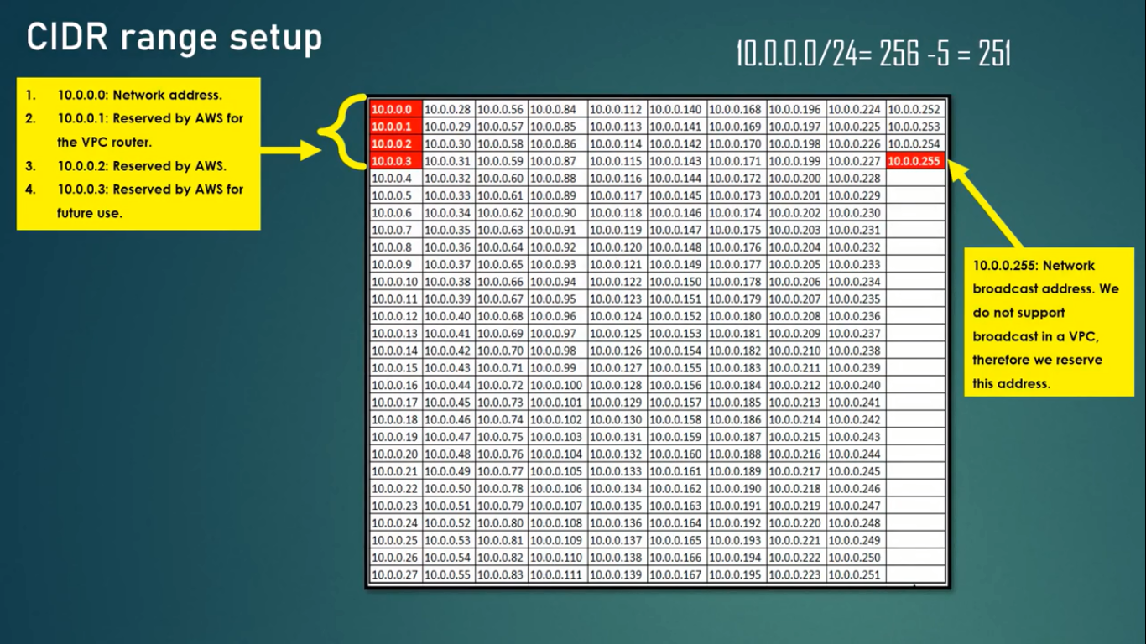

Hands On:

1. Create a VPC in AWS using the following data

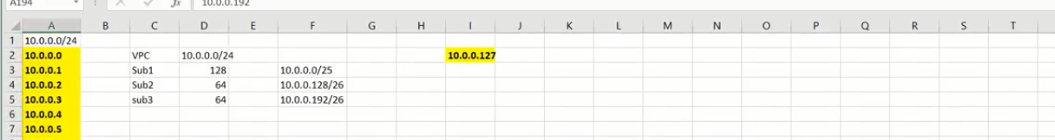

Task 1:

1. Create a VPC with route tables and setup the route.
2. Create 2 Ec2 instances to access one publicly and another privately.

Solution:

1. Go to VPC.
2. Going to create a new VPC with user defined CIDR range.
3. Create VPC with name : MyFirstVPC.
4. Give IPv4 CIDR block range: 10.0.0.0/24
5. The above range will create 256 ip addresses.
6. Cllick on ‘Create VPC’.
7. After creating VPC, select the VPC and check the option ‘Edit DNS Host Names’.

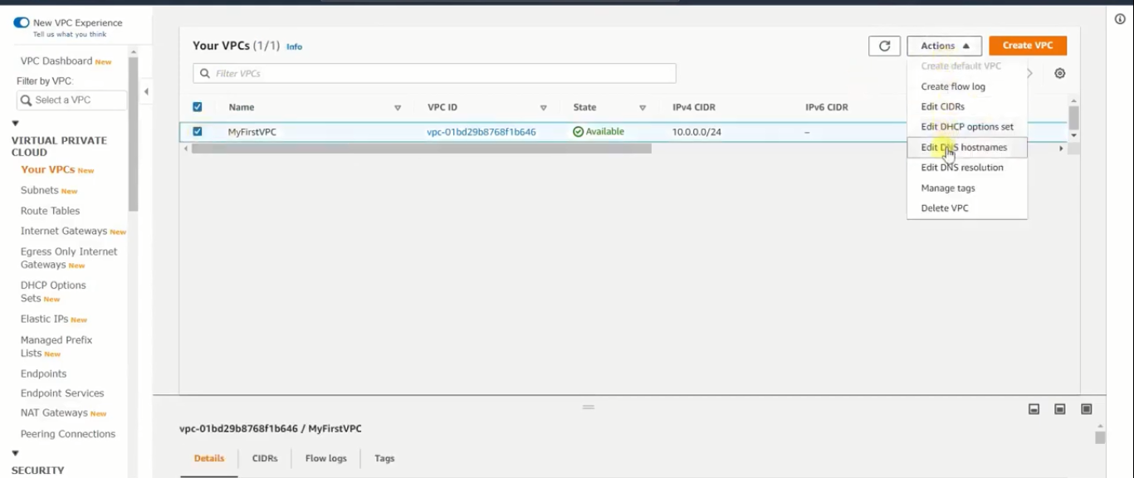

1. Now go to subnets and create 2 subnets each maintaining 128 ip’s.
2. Go to ‘Subnets’. Click ‘Create Subnet’.
3. Select the vpc: MyFirstVPC
4. Subnet name: MyPublicSubnet
5. Select any of you choice AZ.
6. IPv4 CIDR block range for first subnet: 10.0.0.0/25 (creates 0-127 ip addresses).
7. Create Second Subnet Name: MyPrivateSubnet
8. IPv4 CIDR block range for first subnet: 10.0.0.128/25 (creates 128-256 ip addresses).
9. Click ‘Create VPC’.
10. Now attach the create 2 subnets to the Route Table.
11. Before that create an ‘Internet Gateway’.
12. Go to ‘Internet Gateway’ and select ‘Create Internet Gateway’.
13. Name tag: MyFirstIGW
14. Click ‘Create Internet Gateway’.
15. In the next window click on ‘Actions’ and select ‘Attach to VPC’.

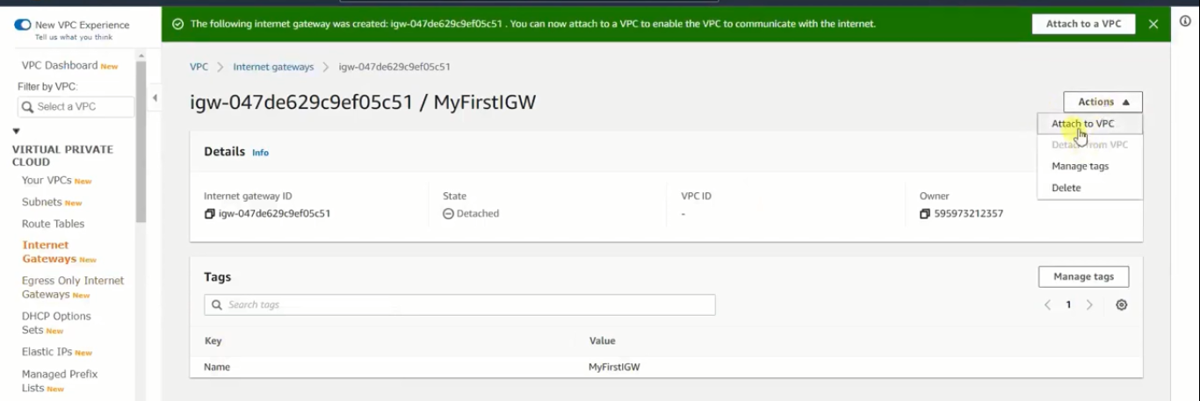

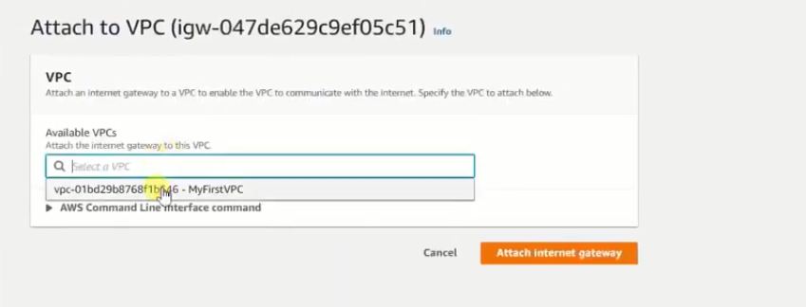

1. Click on the option ‘Route Tables’.
2. Whenever you create a new VPC , automatically a Route Table will be created.
3. This Route table is called ‘Main Route Table’.
4. Apart from that create your own Route table by clicking ‘Create Route Table’.
5. Name Tag: MyFirstRT-Public
6. VPC: MyFirstVPC
7. Cllick ‘Create’.
8. If you click the tab ‘Subnet Associations’ you can see the Subnets.

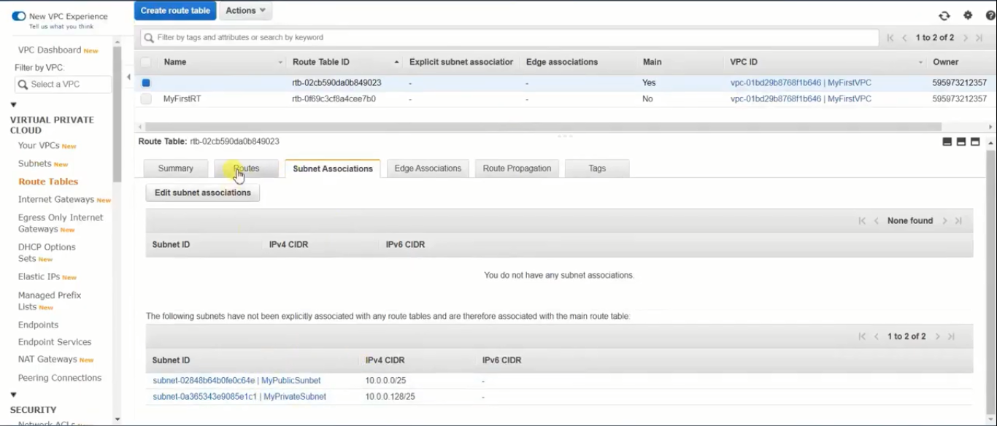

1. Create another route table
2. Name Tag: MySecondRT-Private
3. VPC: MyFirstVPC
4. Click ‘Create’

Subnet Associations:

1. After creating the 2 Route Tables, now we can associate the subnets one as public access and another as private.
2. To do so, go to Route Tables.
3. Select the route table ‘MyFirstRT-Public’.
4. Under Subnet Associations, click ‘Edit Subnet Associations’.
5. Select ‘MyPublicSubnet’ and click ‘Save’.

Create Route Access:

1. Under Route Tables, select ‘MyFirstRT-Public’.
2. Under the tabs, click ‘Routes’ tab.
3. Click ‘Edit Routes’.

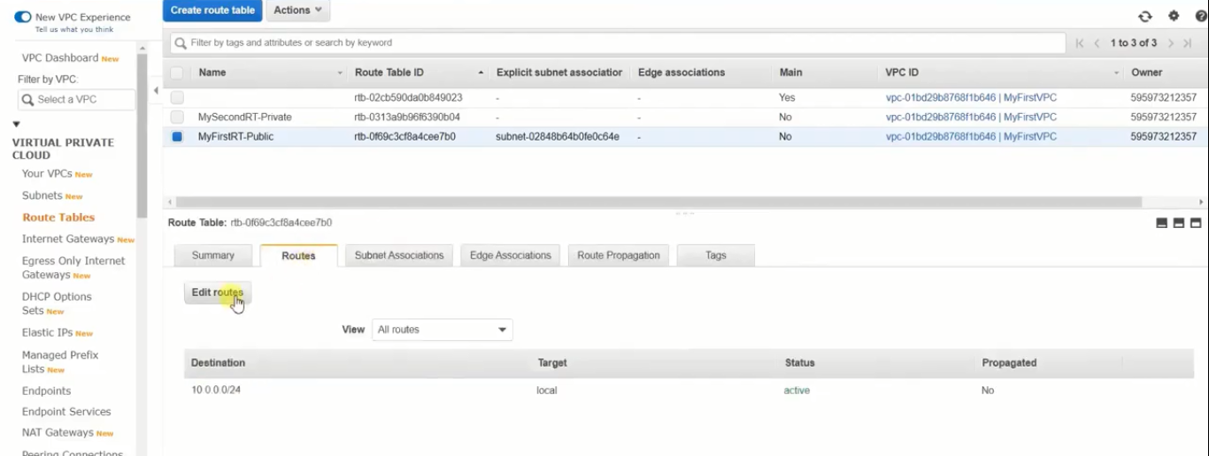

1. There will be a default CIDR range 10.0.0.0/24, which was created when we created ‘MyFirstVPC’. This range is used for internal communication.
2. Apart from that we should add another route for external communication.
3. Click ‘Add route’.
4. Destination: 0.0.0.0/0(all privileges)
5. Target: Internet Gateway, and then select MyFirstIGW.

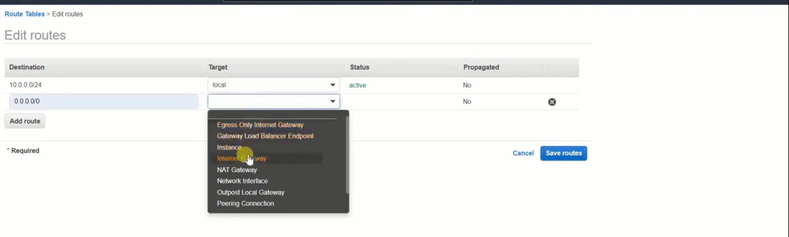

1. Click ‘Save Routes’.
2. From the above procedure we have set a public route through IGW, for Public Subnet.
3. Since, the second subnet ‘MyPrivateSubnet’ need not be a public access, we don’t have to add a new route for external communication.
4. So select ‘MySecondRT-Private’ in Route Tables.
5. Go to ‘Subnet Associations’ and select ‘Edit Subnet Associations’.
6. Select ‘MyPrivateSubnet’ and click ‘Save’.
7. Now we have successfully generated subnet connections.

Create EC2 instances and associate the subnets:

1. Create 2 free tire eligible instances of your choice.
2. While creating first instance, in ‘Configure Instance’ section, select ‘MyFirstVPC’.
3. Subnet: MyPublicSubnet (Doing so will create IGW connectivity, so that I can connect to internet publicly).
4. Auto-assign Public IP: Enable
5. Rest of the steps have no change.
6. Finally create the First instance ‘PublicServer’.
7. In the same way create the second instance with name ‘PrivateServer’, but in ‘Configure Instance’ section,
8. Subnet: MyPrivateSubnet
9. Auto-assign Public Ip: Enable
10. Finally launch the second instance.

Final Inspection:

1. If you connect to the 2 instances and check for the internet connections, then the server with public access can connect to the internet, but the server with private access cannot connect to the internet. It can be used for internal communication only.
2. To provide internet to the private instance, we have to configure the NAT Gateway.

Configuring NAT Gateways for private instances:

1. Select ‘NAT Gateways’ option under VPC.
2. Click ‘Create NAT Gateway’.
3. Name: MyFirstNGW
4. Subnet: MyPublicSubnet
5. Elastic IP Allocation ID: Click ‘Allocate Elastic IP’ **(Careful, this service is chargeable, remove immediately after use)**

**NOTE: To remove Elastic IP, go to Elastic IP section and select the IP and remove.**

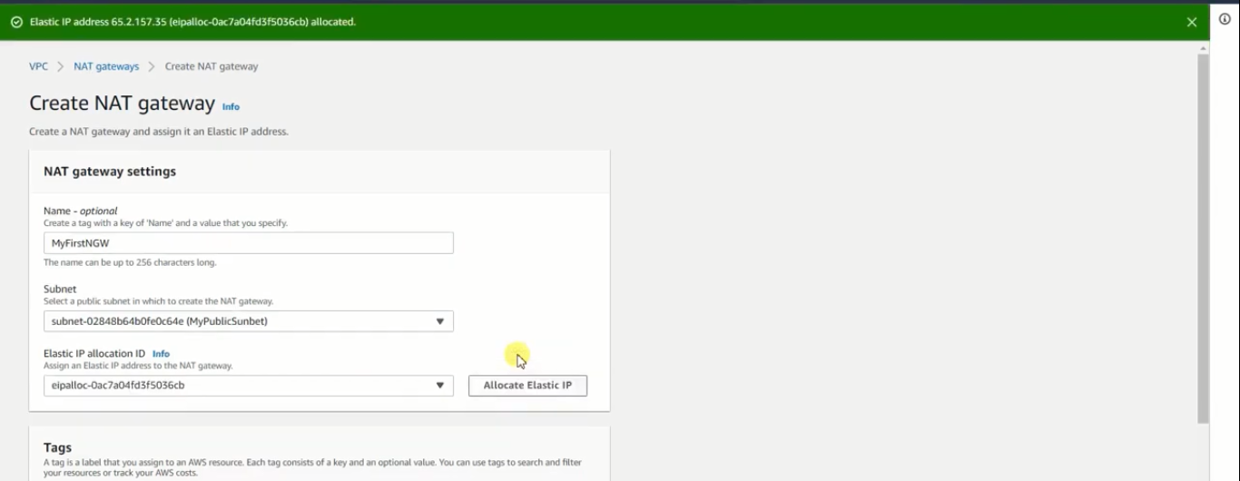

1. Click ‘Create NAT Gateway’.
2. Now go to ‘Route Tables’, select ‘MyFirstRT-Private’.
3. Select the tab ‘Routes’, ‘Edit Routes’.
4. And select the ‘NAT Gateway’ like the following.

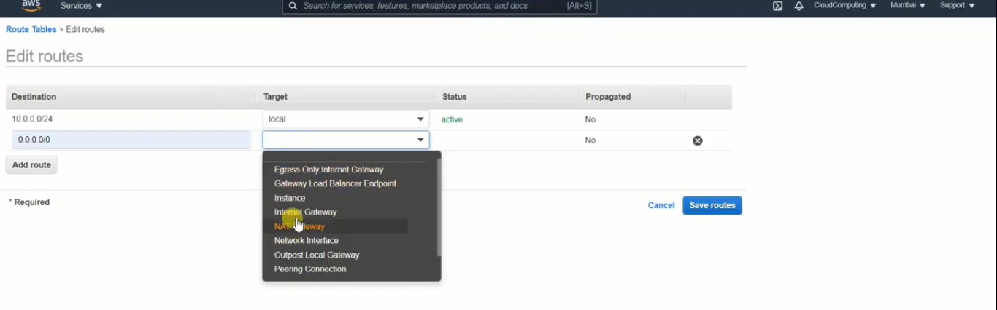

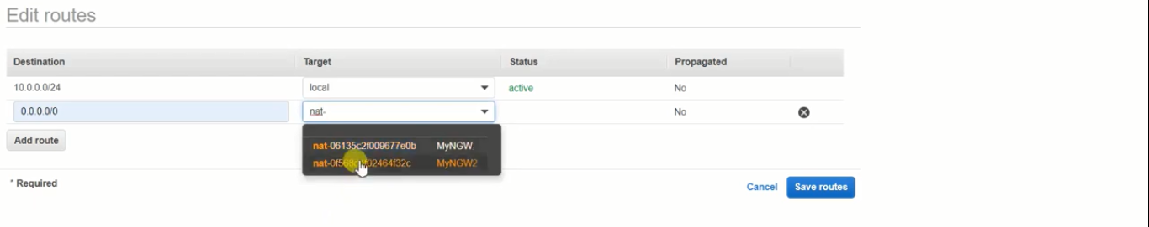

1. Finally, click ‘Save Routes’.
2. Now to the instance with private access and check for internet connection.(It should support internet access now).

***NOTE: This NAT Gateway service is useful when private servers needs internet access for software updates, bug fixes, OS updates, patches etc…***

**NOTE: Now delete NAT Gateways, Elastic IPs, Stop or Terminate instances, and if not necessary remove route tables, IGW, subnets and VPC.**